WExperiment 6: BJT Amp Biasing
Name: Thomas Puskas
Student ID: 2025952293
Objective: To study the operating points of a BJT amplifier by studying the methods of properly setting it. To learn the different types of biasing methods, including resistive divider biasing, emitter degeneration, simple biasing, and self-biasing.
Pre-Lab:

Experiment:
3.1 Simple biasing Procedure:
- Set up the circuit with R_{B}=1MΩ and R_{C} as 2.7kΩ.
- Applied DC voltage to 12V and measure VBC, VCE, IB and IC.
- Calculate beta value.
- The RB is then changed and repeated for data collections.

 | R_{B}=1MΩ | R_{B}=570kΩ
 | Q1 | Q1
V_{BE} [V] | 0.61 | 0.61
V_{CE} [V] | 9.28 | 9.06
I_{B} [µA] | 11.41 | 25.4
I_{C} [mA] | 0.94 | 1.02
β | 82.38 | 40.15
Operating region

Circuit:
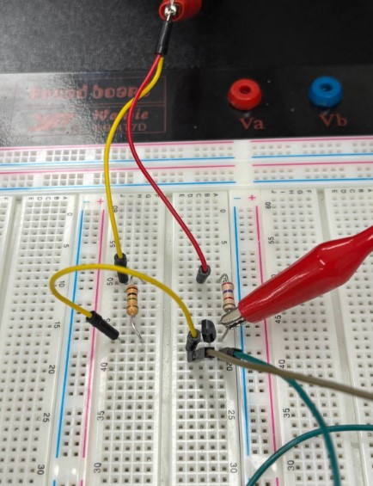
Vce when R_{B}=1MΩ.
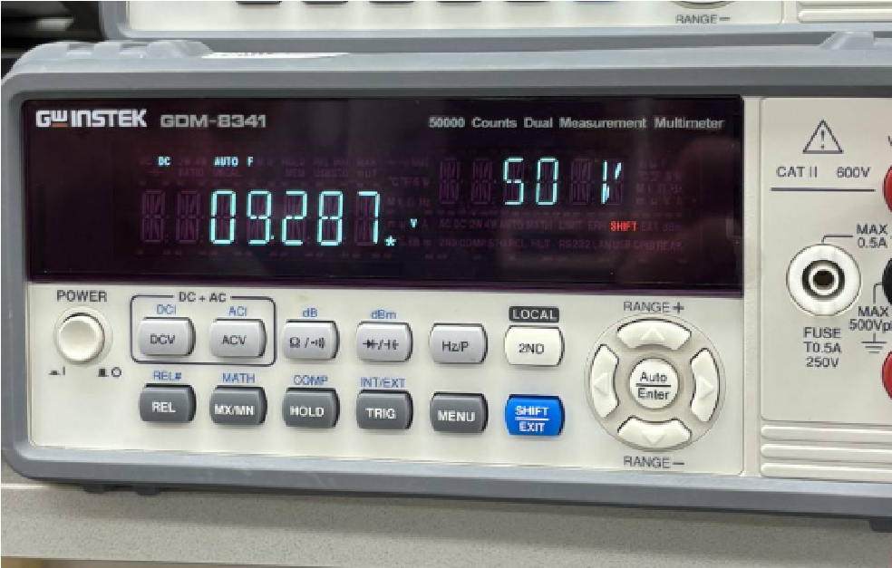
I_{B} when R_{B}=1MΩ.
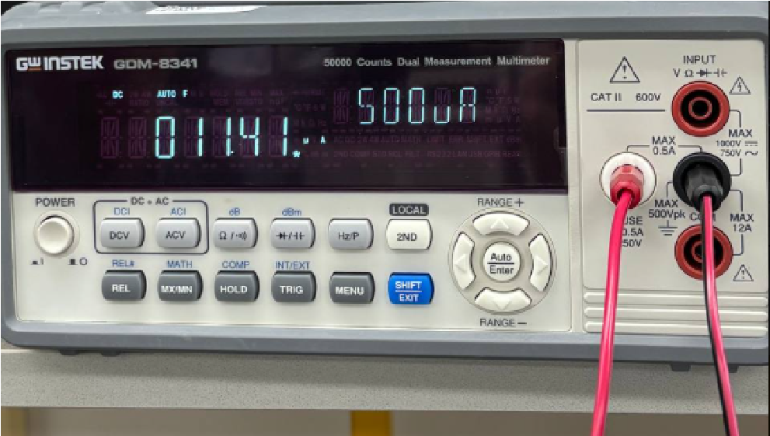
I_{B} when R_{B}=570kΩ.
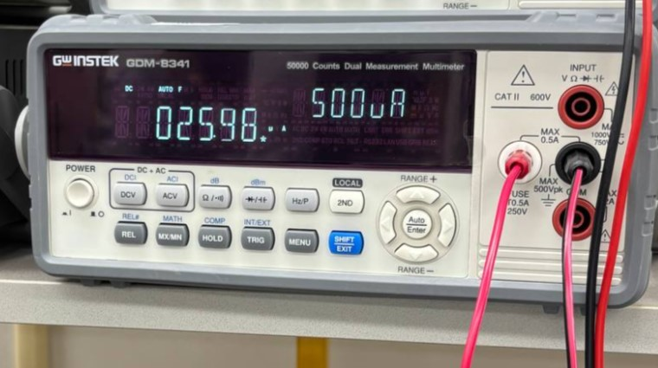
  - Resistive divider biasing
 | R₂=8.2kΩ
V_{BE} [V] | 0.61
V_{CE} [V] | 9.14
I_{B} [µA] | 95.7
I_{C} [mA] | 0.984
β
Operating region

 |  |  | R₂[kΩ]
 | 6.8 |  |  |  | 12
R₂/(R₁+R₂) | 0.053 |  |  |  | 0.090
I_{C} [mA] | 95.5 |  |  |  | 95.5
V_{BE} [V] | 0.61 |  |  |  | 0.61
V_{CE} [V] | 9.4 |  |  |  | 8.80
Operating region

Circuit:
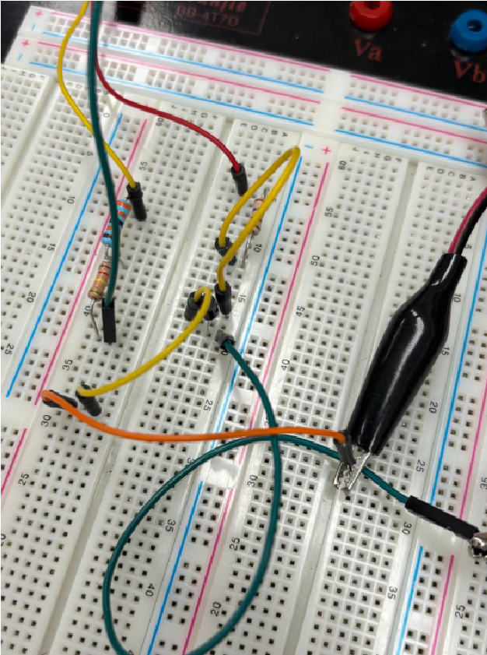
  - Resistive divider biasing with emitter degeneration
 |  | R₂[kΩ]
 | 6.8 | 8.2 | 12
R₂/(R₁+R₂) | 0.053 | 0.063 | 0.090
I_{C} [mA] | 0.347 | 0.526 | 0.724
V_{BE} [V] | 0.766 | 1.30 | 1.02
V_{CE} [V] | 0.992 | 1.48 | 2.048
Operating region

Circuit:
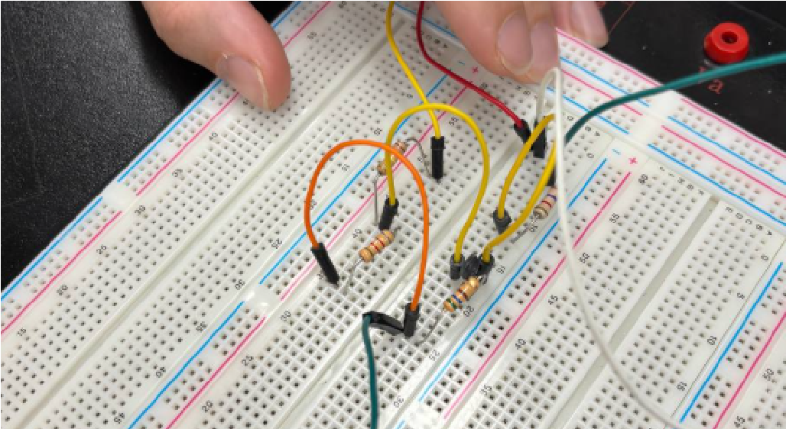
I_{C} when R₂=8.2kΩ.
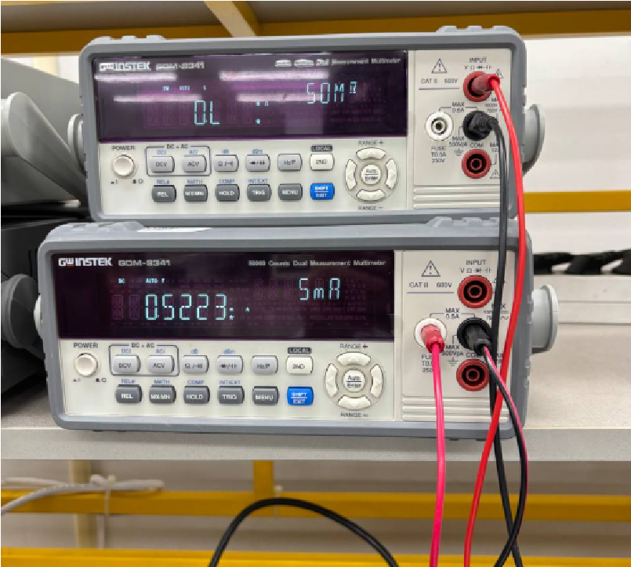
  - Self biasing
 | R_{B} =2.7kΩ | R_{B}=120kΩ | R_{B}=330kΩ
 | Q1 | Q1 | Q1
V_{BE} [V] | 1.55 | 7.87 | 8.44
V_{CE} [V] | 9.73 | 3.46 | 2.90
I_{B} [µA] | 558 | 66.9 | 25.7
I_{C} [mA] | 3.43 | 1.22 | 1.02
β | 6.14 | 18.23 | 39.68
R_{B} /β | 439.73 | 6582.55 | 8316.53
Operating region

Circuit:
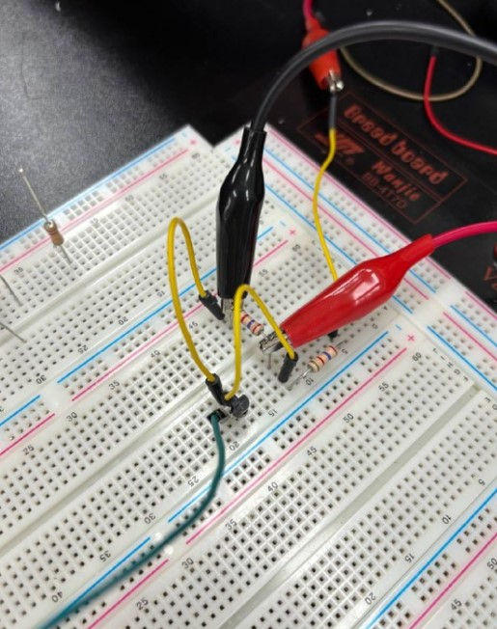

V_{BE} when R_{B}=2.7kΩ.
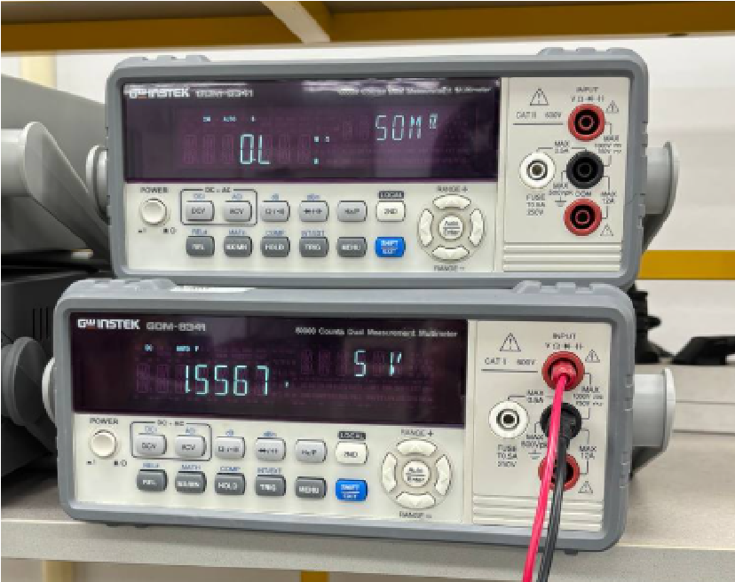

PSPICE

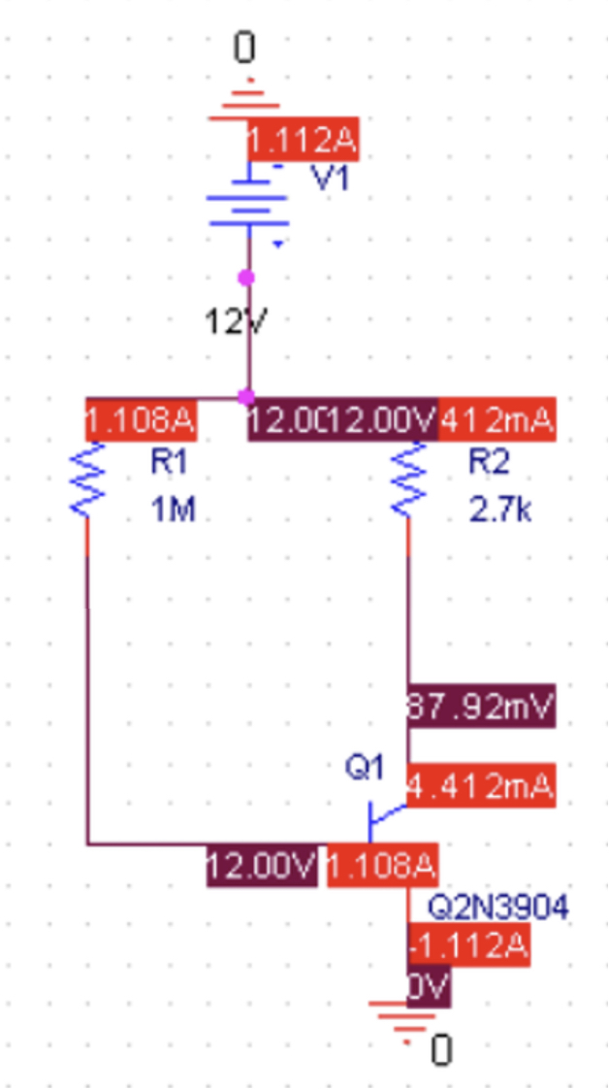
Exp. 3.1

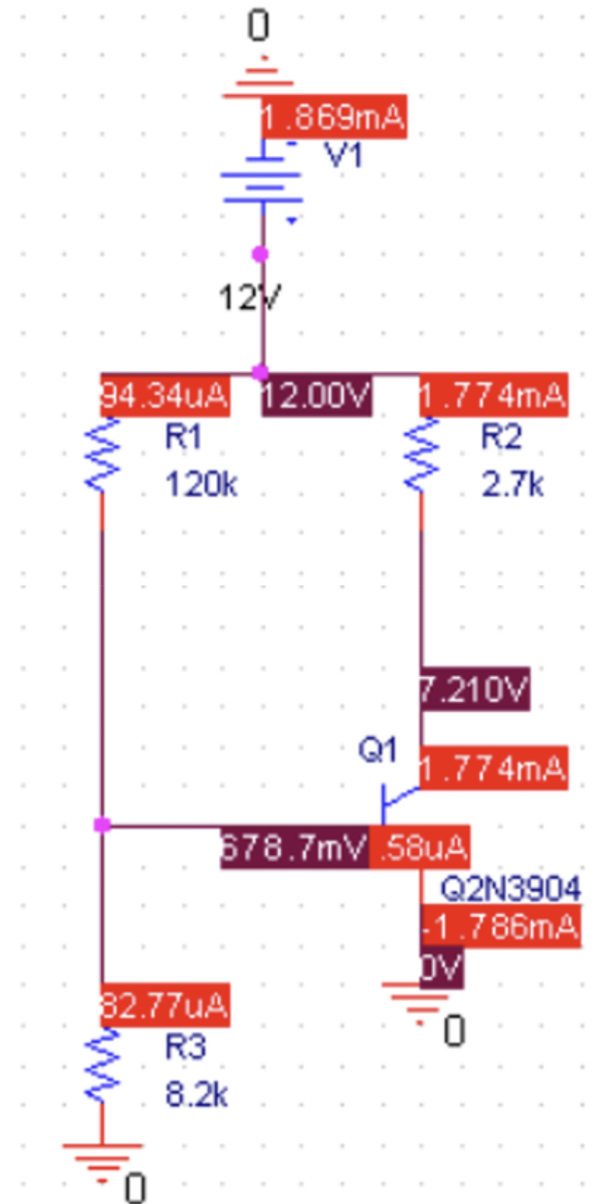
Exp. 3.2

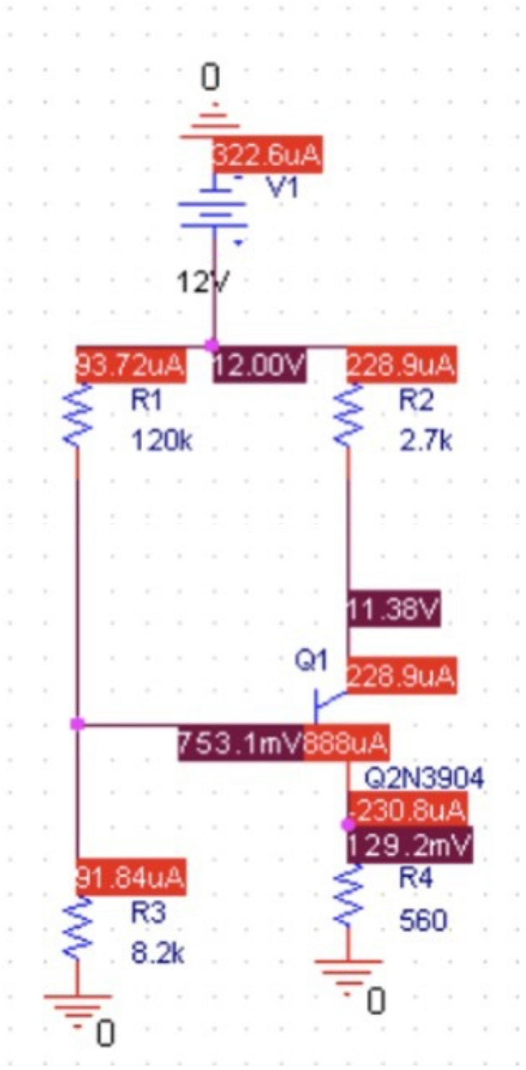
Exp. 3.3

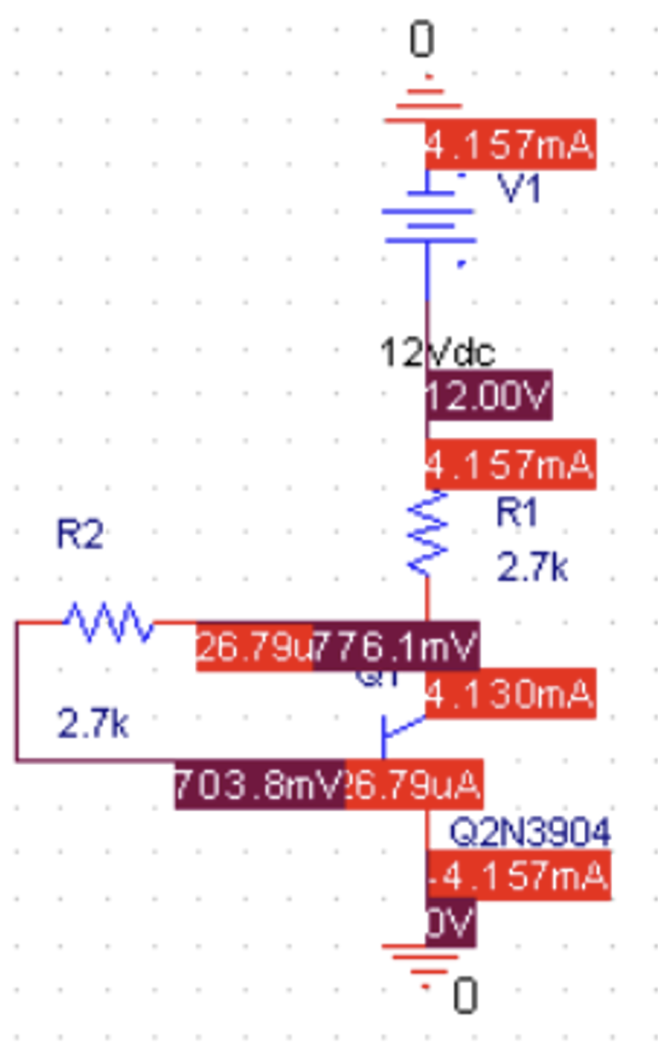
Exp. 3.4

